Jonathan Rothenberg (A12697022)

Ally Reiss (A11889728)

Francisco Ochoai (A12035504)

Kent Tsang (A91081395)

**Meme Report**

The first meme we decided to test we titled, “Died a little inside”. It featured an already popular base meme commonly known as, “Minor Mistake Marvin” and we put our own text on top of it. The class topic we decided to shed light on with our meme was context collapse, where all the widely different social contexts you are apart of collide, most notably on social media.

We realized that if we were to make a meme which would catch on and potentially go viral, it would need to shed light on a something that many people can relate to - something that happens to people all the time. It would need to not only discuss a thought or experience everyone has, but furthermore, it needs be funny. We began thinking of how one feels when experiencing context collapse, and the general consensus was that words to describe it are, “embarrassing, stupid, and accidental”. Thus, we chose Minor Mistake Marvin as the underlying meme because we believed that it fit those words perfectly. To give a little context, the meme Minor Mistake Marvin features a young boy (whose name is Marvin) who has partially burned a ramen noodle soup container after trying to cook it inside of a microwave. After realizing that Marvin had burned his food, a photographer captured his disappointment. After its initial post, the meme instantly blew up, as many people resonated with the boys blank face, which brilliantly described the feeling one feels when making small, seemingly stupid mistakes.

For our meme, we wanted to discuss the topic of context collapse, but in a way that would be less selective in terms of who would understand it and who wouldn’t. Thus, we hypothesized that example outside the social network medium might resonate with more people. Thus, we decided to try and appeal to the students of the internet. The text on our meme reads, “When you ask the professor a question, and call him dad”. To break this down, we first identify what a social context is. A social context is a social group that has explicitly or implicitly understood norms associated with it. These norms define how those in the social group interact and communicate with one another. Each social group (or social context) can have similar or completely different social norms. For example, the way I communicate with my professor is different from the way I communicate with my mom, which is different from the way I communicate with a friend. Thus, as a member of our society, every single one of us are apart of numerous social groups, each with their own norms. So, the idea of context collapse is, again, when all the various social contexts you are apart of collapse. On social networks, context collapse is a natural byproduct of the way they are designed, where all of your social groups are located in one place. One can experience context collapse when making a public Facebook post and all the various people you are friends with on Facebook (your mom, boss, friend, and teacher) all see it. Naturally, the way you converse in one context may not be the same as the way you do in another context, and if the Facebook post you made isn’t geared towards all the different contexts seeing that post, you feel the wrath of context collapse. However, what about those times when one accidentally causes context collapse, like the times you subconsciously take the norms of one context and apply it to other contexts. The example we used looked at the difference between two social contexts, the social group containing your parents, and another social group containing your professor. In the social group containing your parents, you might act in a more loving, open, and sincere way. In the social group containing your professor, your interactions might be defined as professional, honest, and mature. So, by calling your professor “dad” or “mom” and therefore accidentally collapsing two social contexts, you are violating the unwritten norms of that the professor social context (by merging them with the unwritten norms of the loved ones social context), therefore putting yourself in an awkward situation.

In terms of reach, it performed differently across platforms. In total, across all platforms, counting all interactions with the image such as views, upvotes, comments, and likes on comments, it got a total of 3,020 interactions with unique users. Facebook had the best interaction by far, boasting 33 comments, 200 likes, and 29 likes on comments. However, if we consider Imgur alone, it got a total of 2680 total interactions. These interactions on Imgur can be further broken down into 30 upvotes, 19 comments, 29 likes on comments, and 2602 views. 9GAG performed the worst by far, having only 10 points, 3 comments, and only 1 like on comment. Twitter performed better than 9GAG but worse than Imgur in terms of user engagement, with 17 retweets and 13 likes. Most of the comments on the meme across all platforms tended to agree with our sentiment, and share their own personal experiences with this notion of accidental context collapse. This included various gif responses with uncomfortable and awkward facial expressions. All of the comments tended to be in a joking tone, with some commenting other similar minor mistake marvin memes that share the same feeling. As a whole, while everyone who viewed the content agreed with the idea and found it humorous, overall view count was lacking, a sign that the meme wasn’t edgy enough for the current times, or we overvalued the memes reach.

The second meme we created was titled, “Every. Damn. Time.”. It is a variation of the “Disappointed Black Guy” meme, a traditionally four-panel expectation-reality type meme. We used the two right panels in the traditional meme and added our own images to the two left panels. In this artifact, we continued to explore context collapse but this time with a more direct relation to social media, specifically Facebook.

Once again, to foster the sense of understanding needed for a meme to go viral we wanted to make the topic both relatable and funny. We began to think about how context collapse may affect us in our own lives, and when we tend to encounter it most often. We came to the consensus that Facebook is the social media platform in which context collapse occurs most often. Facebook is widely used across different age groups. In our generation, almost everybody has a Facebook. We often use it for scrolling through our feeds and keeping connected with one another. Older generations, such as our parents and older family members, often use Facebook to post life events, pictures, and contact their friends. This mix of generations using Facebook is unlike any other social media platform, where older generations tend to be much less active. This leaves a large opportunity for context collapse, as the younger generation is forced to balance their friends and family on Facebook. For our meme, we decided to leverage one of these awkward moments when having family on Facebook may lead to embarrassment.

The “Disappointed Black Guy” meme perfectly depicts this feeling of worlds colliding unexpectedly, as you can see his excitement quickly turning to disappointment. The first instance of this meme was seen in 2012 on the website weheartit.com. While not much else is known about the meme’s origin, it has been widely used to depict expectations vs. realities. This quick change from excitement to complete disappointment is a relatable feeling for many people, which has caused the meme to go viral and many variations of it have been circulated. We decided to leverage the meme’s viral nature to create and release our own variation.

We wanted our meme to make a statement about context collapse in a simple manner that anybody could understand. In the top left panel, you see that there is a Facebook notification, followed by an excited black man in the top right panel next to it. The third panel then reveals a comment from mom on their profile picture that says “Wow sweetie you look so cute!!!”. This is followed by the black man’s expression changing to disappointed in the final bottom right panel. The sequence of events is easy to follow for anybody who has used Facebook, which we assume almost everybody who will see our meme has. For the top half of the meme, we focused on the feeling of excitement that people get when they see that they have a notification. With social media, notifications often signify that somebody has interacted with you in some manner, and this comes since a sense of social verification. People often focus on how many likes or comments their posts get, as this is often used as a factor of how well you are liked or how popular you are on social media. This is within the social context of his peers and friends. However, when he opens the notification to see that his mom was the one who commented on his profile picture, his face turns to disappointment. When he posted the picture, he was hoping to get recognition from his peers, and was probably hoping a friend had commented. Instead, this second familial context in his life has come into play. His mom has publically called him “cute” on his profile picture, which comes with a sense of embarrassment since all of his friends will now see this comment. This is a relatable feeling for many people. Nobody wants to be called “cute” by their mom in front of their friends, whether it be in a physical or virtual setting. This leaves him with a sense of unease and awkwardness, as his familial social context is now overlapping with his peer-based social context.

In total, across all platforms, counting all interactions with the image such as views, upvotes, comments, and likes on comments, it got a total of 3,149 interactions with unique users. This consisted of 2,934 imgur views, 102 9GAG points, 38 imgur upvotes, 16 total comments, 32 likes on comments, and 12 retweets and 15 likes on twitter. Unfortunately, the mods of UCSD’s meme page rejected the “Every. Damn. Time.” meme, so we weren’t able to collect reactions on that medium. Many of the comments on the meme focused on how people related to the sentiment, sharing their own examples of context collapse. People described what kind of comments their own mothers make on their social media, while others made comments such as “Hi Mom!” and “Aww mom”. There were also a few comments showing sympathy and a sense of understanding for the awkward situation. Overall, people who saw the meme seemed to relate to the content and found it funny, although the overall view count was not as high as we had hoped.

Between “Every. Damn. Time.” and “Died a little inside”, “Every. Damn. Time” was more popular across more platforms with each repost boasting consistently more views and viewer engagement (such as comments, upvotes, and emotes). Both were posted multiple times across Facebook, Imgur, Twitter, and 9GAG at various times of day. It should be noted that the reaction to the “Died a little inside” meme on UCSD’s meme Facebook page had the most viewer interaction by far, above any other platform we posted on for either meme. However, because we were only able to get one of our memes on it, we decided to conduct our analysis on all platforms that we could get both memes on. Thus, when comparing fair user reception, “Every. Damn. Time” consistently received more views, more upvotes, and more points (for 9GAG). The idea behind both memes were simply to use the concept of context collapse and relate them to something that most every young adult has either witnessed or experienced personally. Thus, we tested two different hypotheses that we believed would resonate with the most amount of people. For “Died a little inside”, we tried to relate to the students of the internet, shedding light on those embarrassing moments they’ve experienced when they accidentally shared the norms of one context with the norms of another in the classroom. For “Every. Damn. Time”, we tried to relate with social media users as a whole, not just students (a seemingly bigger pool of people and possibly more inclusive), and joked about the natural human desire to be popular and liked by your peers. We observed that not only did “Every. Damn. Time” get more views, it also inspired deeper forms of engagement, such as likes, shares, comments, and replies to comments. We concluded the overall success of “Every. Damn. Time” over “Died a little inside” could be attributed to the fact that a broader range of people related to the meme. What we realized, is that we were posting these memes online, and more specifically to social media platforms. Thus, the pool of people who would relate to the student meme is naturally a smaller pool of people, as it is a sample of the bigger pool of social media users. However, it should be noted that when posting to a platform that contained solely students, our student directed meme excelled, most likely do to its ability to resonate with the target demographic. However, it now seems almost obvious that the meme related to social media use would be more popular across all platforms, as it is much more inclusive of the pool of users we were working with. Unfortunately, even though “Every. Damn. Time” did relatively better than “Died a little inside”, it still didn’t perform that well overall. At around 3,149 unique interactions, it is safe to say that the meme didn’t go viral, and as a whole, not too many people found the idea unique enough to view or interact with it. There could be many reasons for this. Most likely, it could be that this meme has been done before (in some capacity), and those that saw it found it to be old news. It could also be related to the time of day that we were posting the memes. For example, we found that if we posted the memes around 3 PM, they all got more views, relative to how they performed previously. If we posted late at night, they got much less views. So, it could also be that we weren’t posting the memes at a time when they would be most well received, or when the most users were active on the platform we posted to. Lastly, it could simply be that the humor we used wasn’t current or relatable enough. It seems as though many popular memes nowadays are very current, and use jokes that relate to what is currently happening in the world today. While our meme was relatable, it wasn’t current. This may have been a big contributor to its underwhelming performance. As a whole, we think we missed the mark in trying to create a viral internet meme. However, we still do believe that our idea was funny and relatable, that the topic we chose from class was something everyone has experienced or witnessed in their daily lives, and the underlying memes chosen were good. Maybe all we really needed to do was study other currently successful memes and analyzed the factors leading to their success.

**Appendix**

***Side Note:*** *while we only show screenshots of views for each posting, we don’t share the context in which each was posted. Thus, it should be noted that we posted each meme multiple times on each platform on different days and at different times of day, to maximize reach. To find every single posting of our artifact online, find the document titled, “Where the Artifacts Exist Online” which contains links to every post.*

**Meme 1 - “Died a little inside” Facebook Submission**

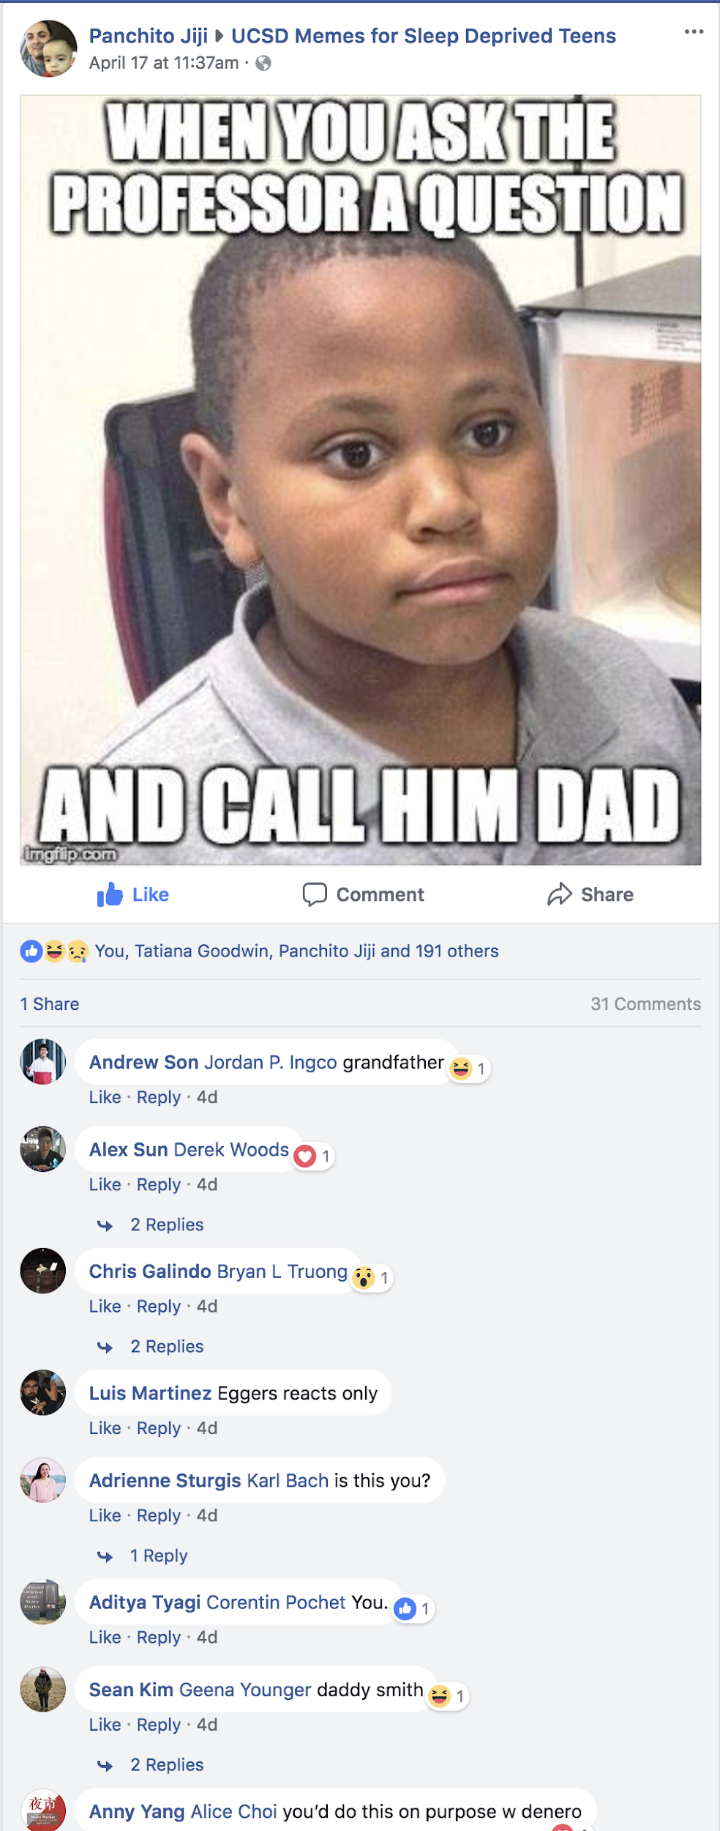



**Imgur Submissions**

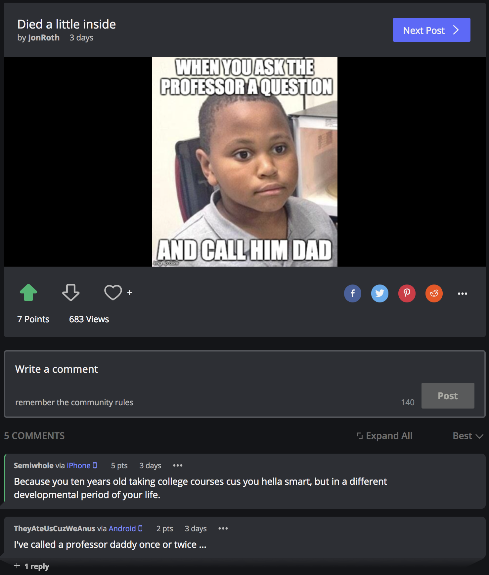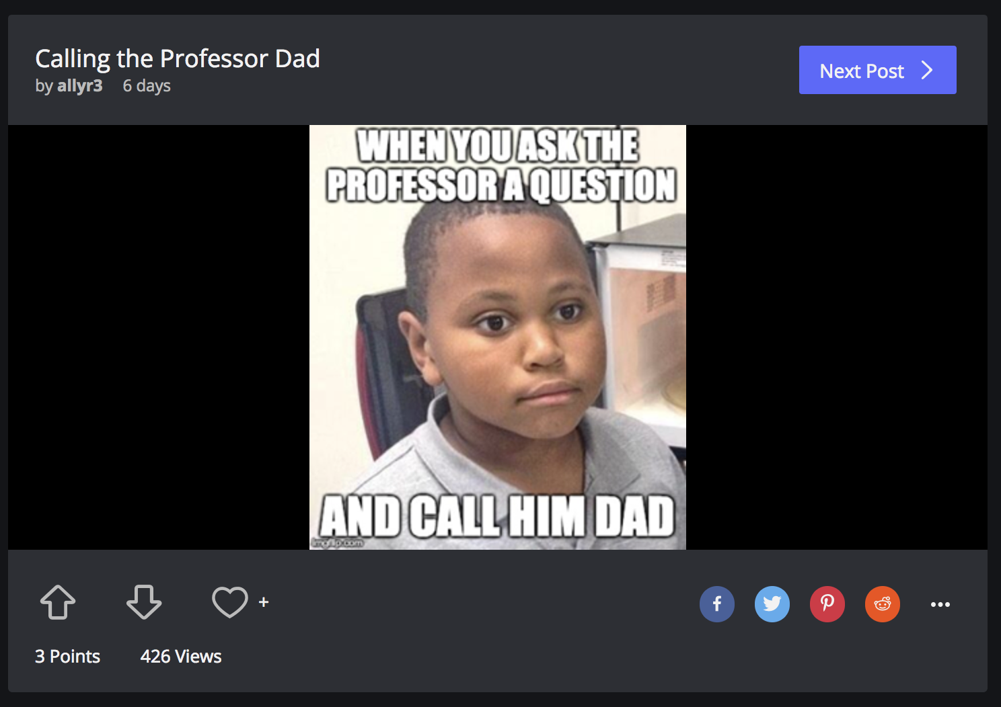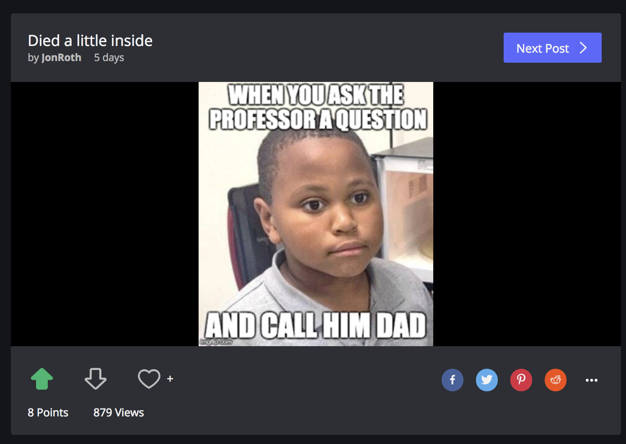

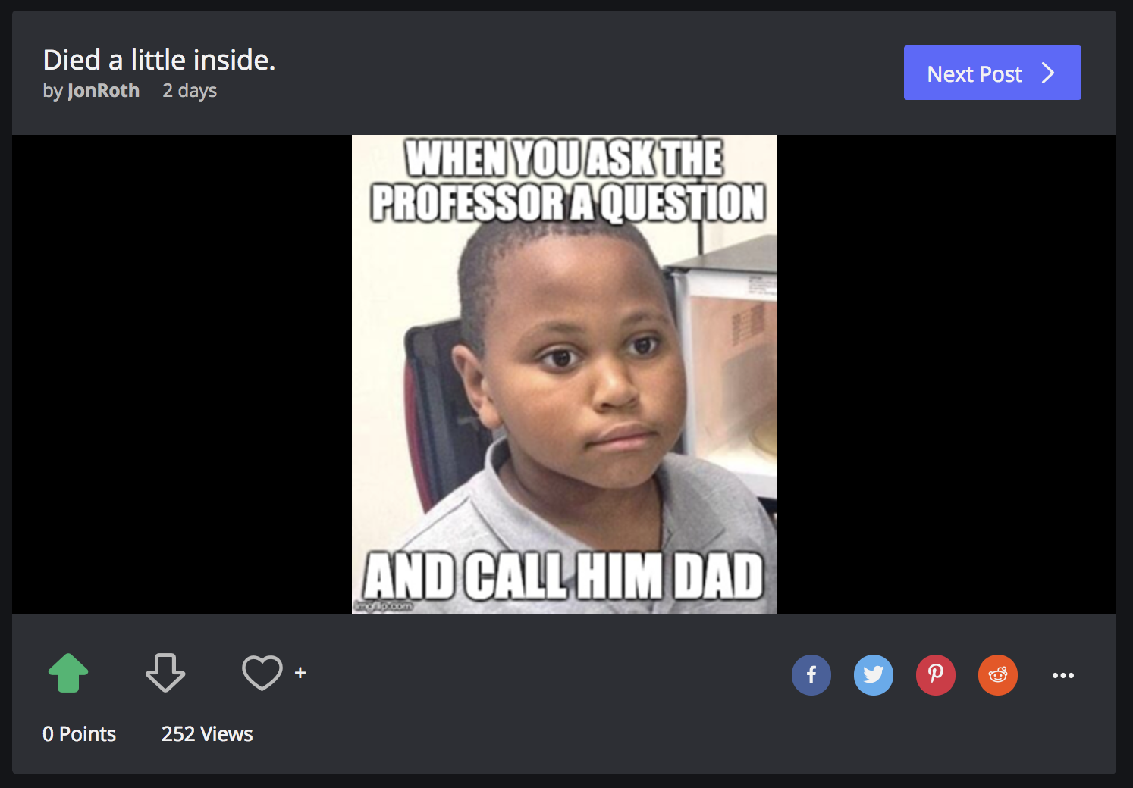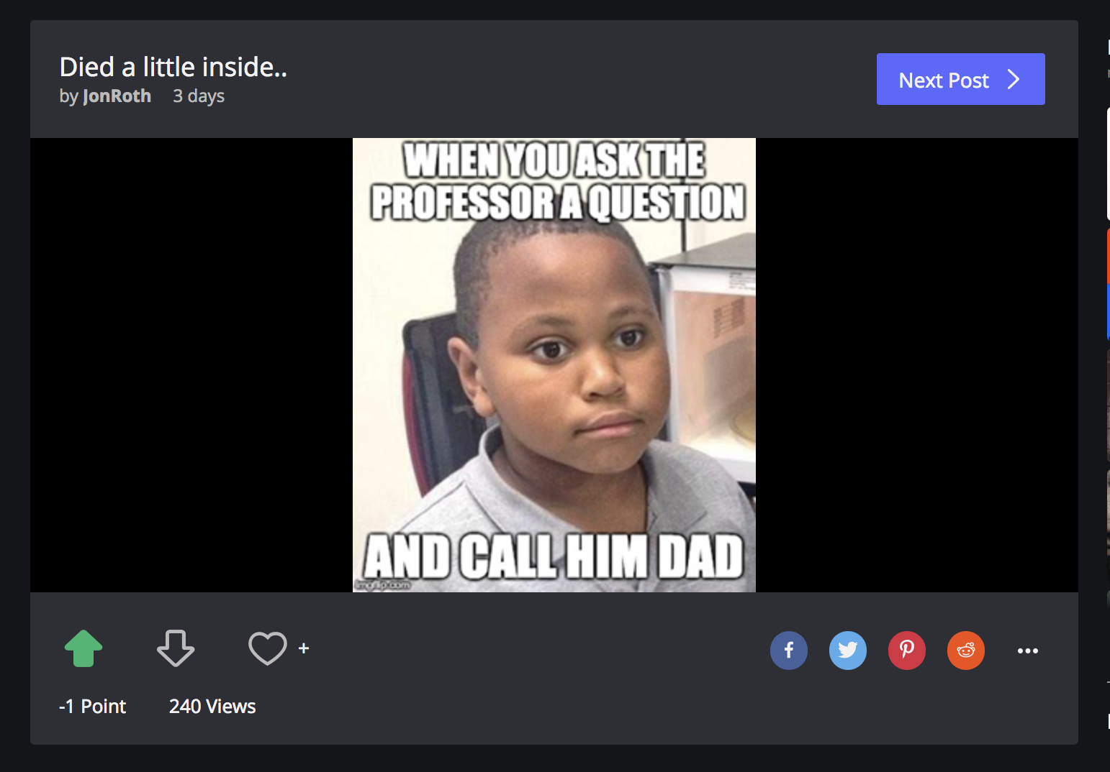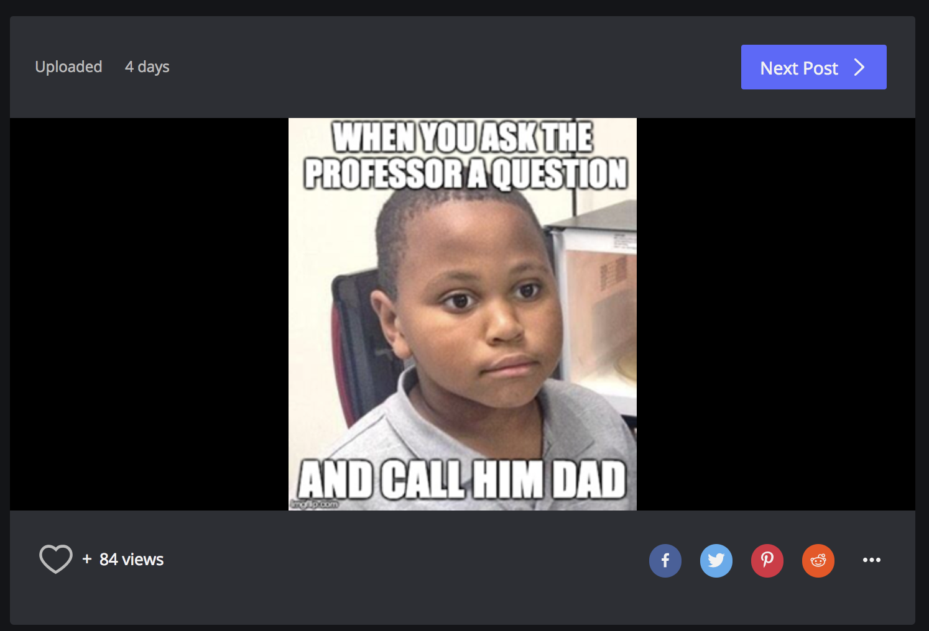

**9GAG**

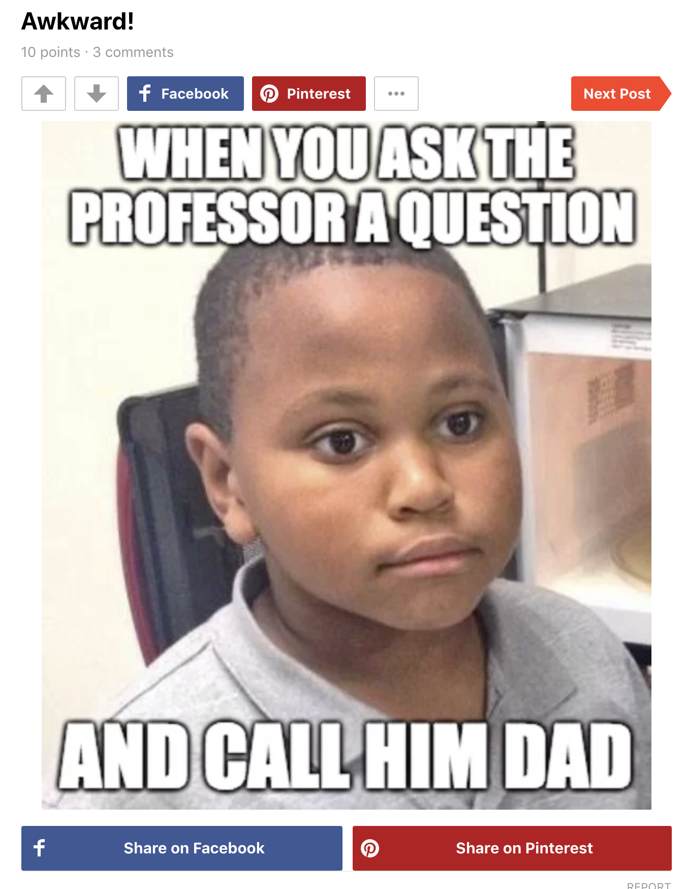

**Twitter**

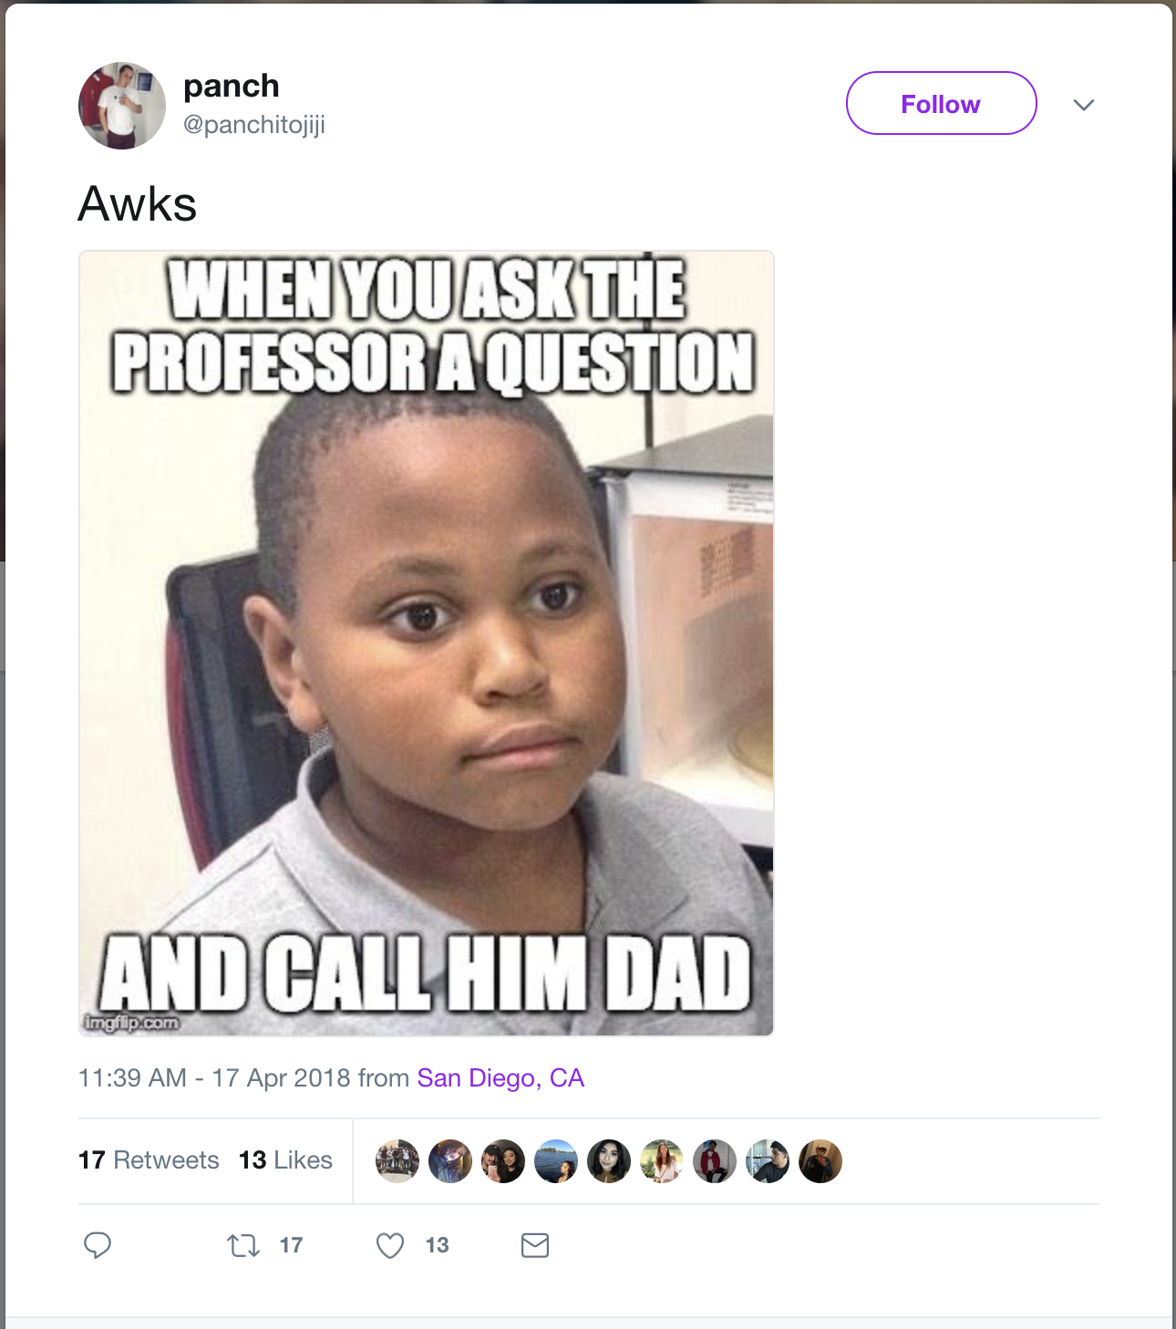

**Meme 2 - “Every. Damn. Time.”**

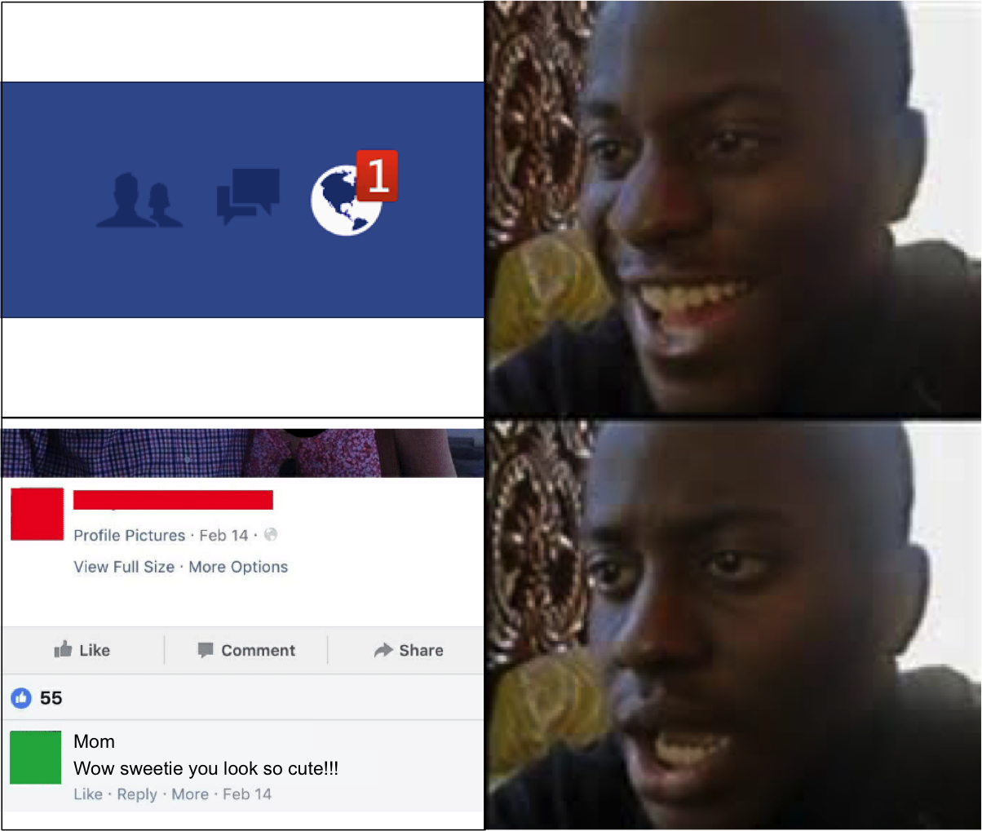

**Imgur Submissions/View counts**

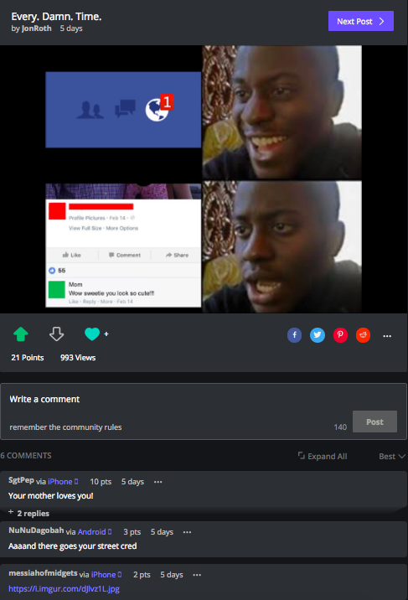

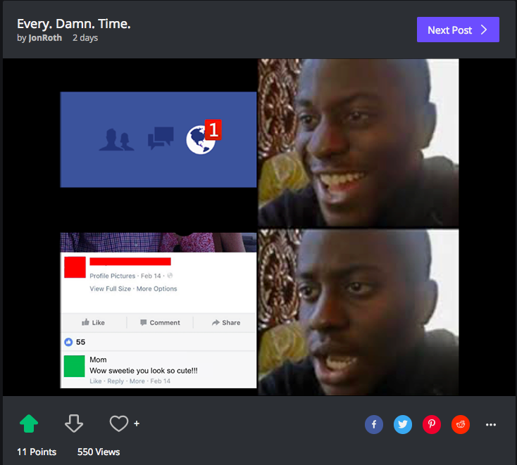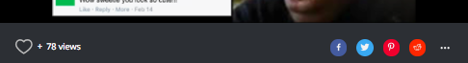

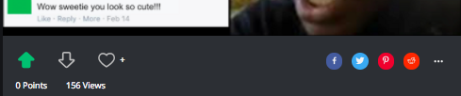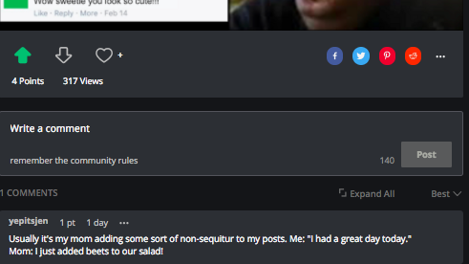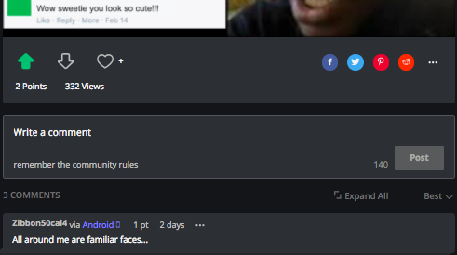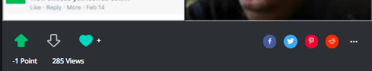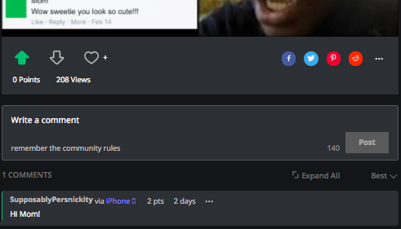

**Twitter Post 9gag**

